MINOR REPORT

ON

**STUDY AND IMPLEMENTATION OF TEMPERATURE INDICATOR USING ARDUINO**

Submitted in partial fulfillment of the requirement for the award of degree of

BACHELOR OF TECHNOLOGY

IN

ELECTRONICS AND COMMUNICATION ENGINEERING

**SUBMITTED BY:**

ESHANT SAGAR (2K14/EC/067)

HAMAAD ULLAH ZUBERI (2K14/EC/074)

PRASHANT KUMAR (2K14/EC/111)

PAWAN KUMAR (2K14/EC/112)

**UNDER THE GUIDANCE OF:**

Mr. DEVA NAND

(ASSISTANT PROFESSOR)



DEPARTMENT OF ELECTRONICS AND COMMUNICATION ENGINEERING

DELHI TECHNOLOGICAL UNIVERSITY

BAWANA ROAD, DELHI-110042

(NOVEMBER, 2016)

# DECLARATION

This is to certify that the Self-Study entitled “Study and Implementations of Temperature Indicator Using Arduino” prepared by us submitted in the partial fulfilment of the requirement for the award of degree of Bachelor of Technology in Electronics and Communication Engineering. Further, it stated that it is a bonafide record of the work done by us under guidance of Mr. Deva Nand, Assistant Professor, ECE Department, DTU. To the best of our knowledge, this work has not been submitted earlier/anywhere for similar project.

ESHANT SAGAR (2K14/EC/067)

HAMAAD ULLAH ZUBERI (2K14/EC/074)

PRASHANT KUMAR (2K14/EC/111)

PAWAN KUMAR (2K14/EC/112)

Department of Electronics and Communication Engineering

Delhi Technological University

# ACKNOWLEDGMENT

We have taken efforts in this project. However, it would not have been possible without the kind support and help of many individuals. We would like to extend our sincere thanks to all of them.

We would like to thank our professor **Mr. Deva Nand** for giving us this opportunity to do this project.

We would like to express our gratitude towards him and also thankful to him for giving us this opportunity to compile this project.

Our thanks and appreciations also go to all our friends and seniors in developing the project and people who have willingly helped us out with their abilities.INDEX

1. ABSTRACT1
2. INTRODUCTION2
3. COMPONENTS4
   1. LM35 TEMPERATURE SENSOR4
   2. ARDUINO UNO4
   3. 20x4 CHARACTER LCD MODULE JHD 204A 6
4. DESIGN8
5. IMPLEMENTATION10
6. ARDUINO SOURCE CODE12
7. REFERENCES14

# FIGURES

1. LM35 TEMPERATURE IC 4
2. ARDUINO UNO PINS AND COMPONENTS5
3. ARDUINO AND ATMEGA 328 PIN DIAGRAM5
4. LCD INTERFACING WITH ARDUINO6
5. BLOCK DIAGRAM OF TEMPERATURE INDICATOR8
6. CIRCUIT OF TEMPERATURE INDICATOR9
7. FINAL IMPELEMENTATION10

# ABSTRACT

This Temperature Indicator is designed and built using an Arduino which gives the temperature in four different units, i.e., Fahrenheit, Celsius, Réaumur and Kelvin. Temperature is displayed on a LCD Screen with an accuracy of 0.1oC. The problems encountered when implementing using PIC are also discussed.

# INTRODUCTION

Temperature is defined as the energy level of matter which can be evidenced by some change in that matter. Temperature sensors come in a wide variety and have one thing in common: they all measure temperature by sensing some change in a physical characteristic.

There are many different devices which are used to measure temperature and display it either using Digital or Analog methods.

1. Thermocouples

Thermocouples are voltage devices that indicate temperature by measuring a change in voltage. As temperature goes up, the output voltage of the thermocouple rises - not necessarily linearly.

2. Resistive Temperature Devices

Resistive temperature devices also are electrical. Rather than using a voltage as the thermocouple does, they take advantage of another characteristic of matter which changes with temperature - its resistance.

3. Infrared Sensors

Infrared sensors are non-contacting sensors. If an infrared sensor is held in front of a desk without contact, the sensor will tell you the temperature of the desk by virtue of its radiation - probably 68°F at normal room temperature.

4. Bimetallic Devices

Bimetallic devices take advantage of the expansion of metals when they are heated. In these devices, two metals are bonded together and mechanically linked to a pointer. When heated, one side of the bimetallic strip will expand more than the other. And when geared properly to a pointer, the temperature is indicated.

5. Thermometers

Thermometers are well-known liquid expansion devices. Generally speaking, they come in two main classifications: the mercury type and the organic, usually red, liquid type. The distinction between the two is notable, because mercury devices have certain limitations when it comes to how they can be safely transported or shipped.

6. Change of State Sensors

Change-of-state temperature sensors measure just that - a change in the state of a material brought about by a change in temperature, as in a change from ice to water and then to steam.

7. Silicon Diode

The silicon diode sensor is a device that has been developed specifically for the cryogenic temperature range. Essentially, they are linear devices where the conductivity of the diode increases linearly in the low cryogenic regions.

# COMPONENTS

## LM35 Temperature Sensor

The Temperature Indicator designed uses a LM35 Sensor. LM35 is a precision IC temperature sensor with its output proportional to the temperature (in oC). The sensor circuitry is sealed and therefore it is not subjected to oxidation and other processes. With LM35, temperature can be measured more accurately than with a thermistor. It also possesses low self-heating and does not cause more than 0.1 oC temperature rise in still air.

The operating temperature range is from -55°C to 150°C. The output voltage varies by 10mV in response to every oC rise/fall in ambient temperature, i.e., its scale factor is 0.01 V/°C.

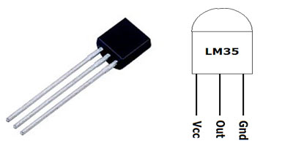

Figure 1. LM35 Temperature IC

## Arduino Uno

Arduino is an open-source electronics platform based on easy-to-use hardware and software. Arduino used is Arduino Uno which is a microcontroller board based on the ATmega328P. It has 14 digital input/output pins (of which 6 can be used as PWM outputs), 6 analog inputs, a 16 MHz quartz crystal, a USB connection, a power jack, an ICSP header and a reset button.

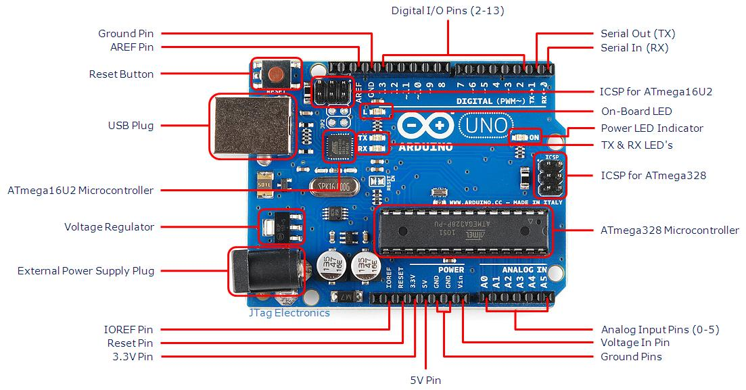

Figure 2. Arduino Uno Pins and Components

The microcontroller IC used in Uno is ATmega328 which has 32 KB (with 0.5 KB occupied by the bootloader). It also has 2 KB of SRAM and 1 KB of EEPROM.

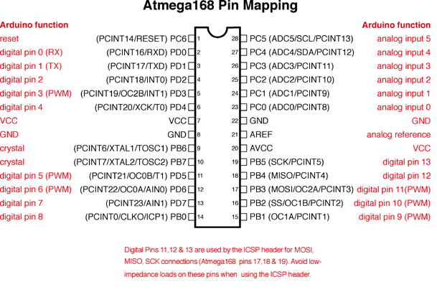

Figure 3. Arduino and ATmega328 Pin Diagram

20x4 Character LCD Module JHD 204A

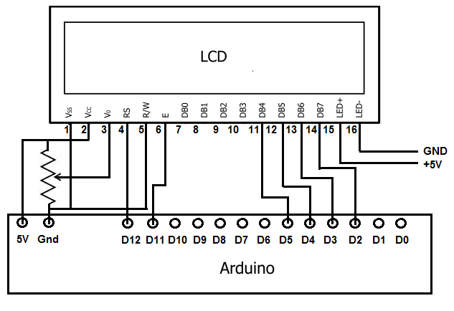

Figure 4. LCD Interfacing with Arduino

JHD204A is a basic 20 character by 4-line display. It utilizes the extremely common HD44780 parallel interface chipset. Interface code is freely available. There 11 general I/O pins to interface to this LCD screen. The module includes LED backlight.

|  |  |  |  |
| --- | --- | --- | --- |
| Pin No. | Symbol | External Connection | Function |
| 1 | VSS | Power Supply | Signal Ground for LCM(GND) |
| 2 | VDD | Power Supply for logic (+5 V) for LCM |
| 3 | VS | Contrast Adjust |
| 4 | RS | MPU | Register Select Signal |
| 5 | R/W | MPU | Read / Write Select Signal |
| 6 | E | MPU | Operation (data read / write) enable signal |
| 7-10 | DB0-DB3 | MPU | Four low order bi-directional three-state data bus lines. Used for data transfer between the MPU and the LCM. There four are not used during 4-bit operation |
| 11-14 | DB4-DB7 | MPU | Four high order bi-directional three-state data bus lines. Used for data transfer between the MPU |
| 15 | LED+ | LED BKL Power Supply | Power Supply for BKL (Anode) |
| 16 | LED- | Power Supply for BKL (GND) |

Table 1. LCD Pins

# DESIGN

The designed Temperature Indicator used an Arduino for reading the analog data from the temperature sensor LM35 and converts it into a digital value. The digital value is then converted to Celsius and thus the temperature is recorded. The Celsius reading is them converted to different units using the formulas given below:

Figure 4. Block Diagram of Temperature Indicator

Battery

LM35 Sensor

Arduino Uno

LCD Screen

The circuit for the Indicator was drawn on Proteus.

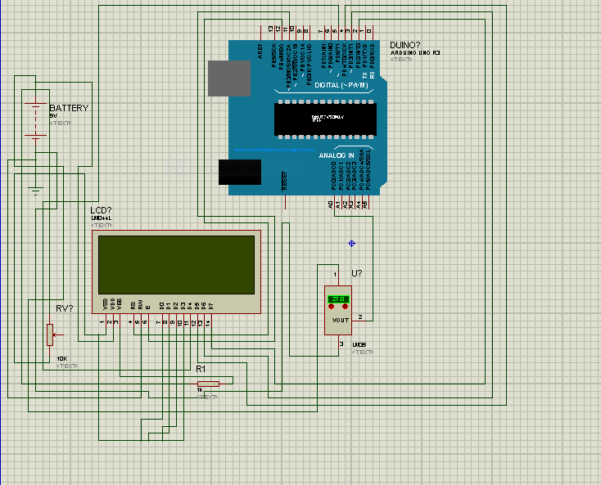

Figure 5. Circuit of Temperature Indicator

Originally, the same project using pic16F877a was designed [1]. Due various problems encountered during its implementation, it was decided use Arduino. PIC chip made the project complicated but by implementing using Arduino, the complexity as well as the cost decreased. Programming the PIC was also found to be very difficult as it requires a special programmer which is difficult to find in the market. Arduino is a platform which is familiar than PIC.

# IMPLEMENTATION

The designed Temperature Indicator was implement on a general-purpose board and all the components were soldered according the circuit.

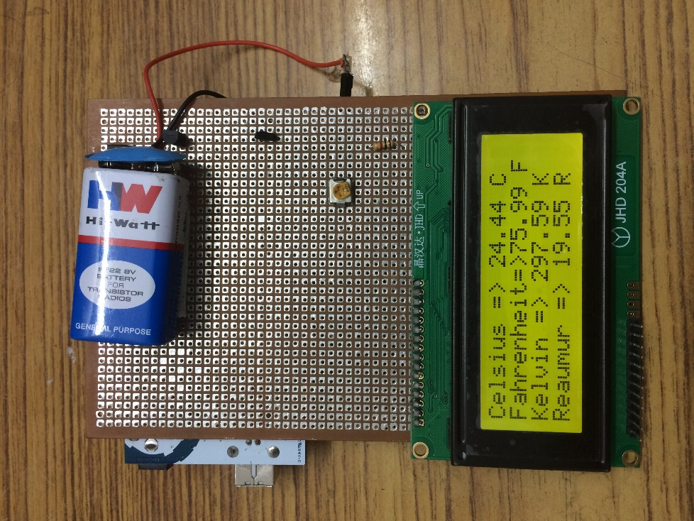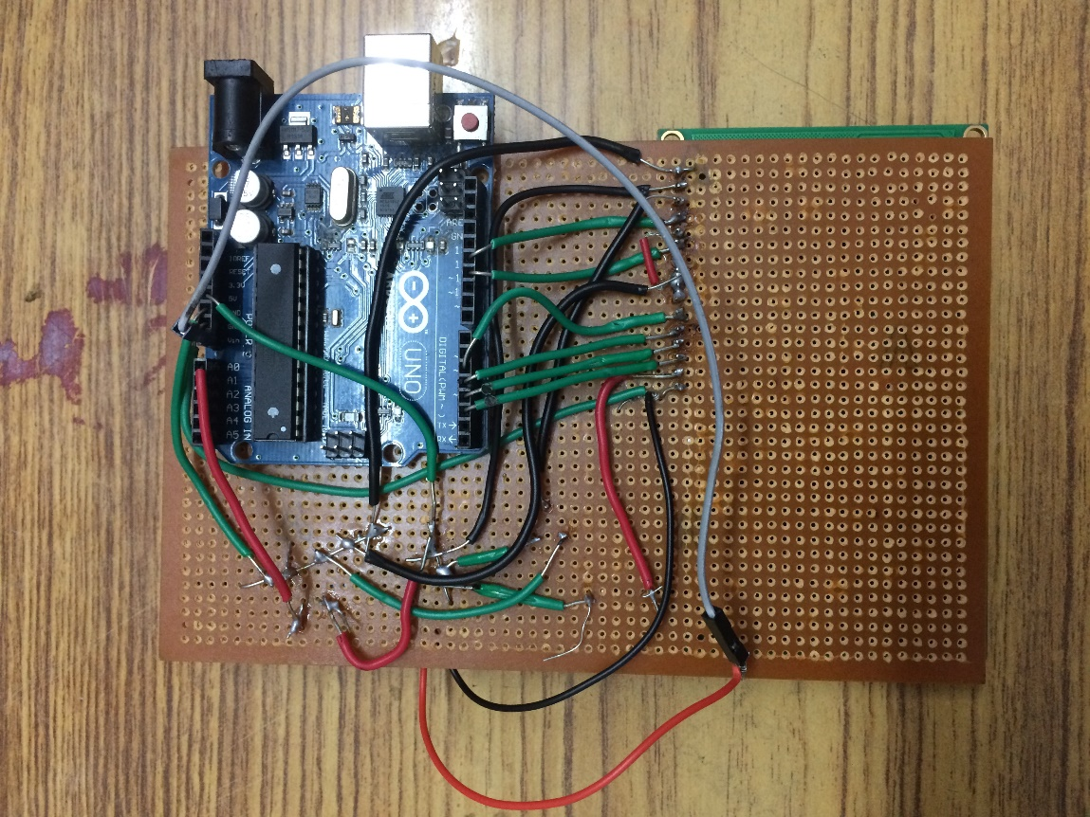

Figure 6. Final Implementation

Arduino is inexpensive and more easily available when compared to other microcontrollers. It allows for easy programming and the circuits created using it are easy to implement. Arduino is open source and has extensible hardware. It is also more familiar than any other microcontroller. The vast dedicated community of Arduino users online makes it very easy to rectify and correct the errors that may occur during the designing and implementation of any circuit.

Making an Arduino based circuit is relatively cheaper than using a PIC based circuit since a PIC based circuit requires more components and special programmer is needed for programming the PIC. In Arduino, the programming is very simple and it’s done in C++ on the Arduino IDE. Arduino is easier to troubleshoot since it is more widely used than any PIC. It is an open source hardware and very easily available in the market. Using the PIC chip resulted in the circuit being complicated which also made it more difficult to troubleshoot.

# ARDUINO SOURCE CODE

#include <LiquidCrystal.h>

LiquidCrystal lcd(12, 11, 5, 4, 3, 2);

int sensorPin = A0;

int sensorValue = 0;

float F;

float K;

float R;

void setup()

{

lcd.begin(20, 4);

// Print a message to the LCD.

lcd.print("TEMPERATURE");

lcd.setCursor(0,1);

lcd.print("INDICATOR");

delay(2000);

lcd.clear();

}

void loop()

{

sensorValue = analogRead(sensorPin);

Serial.println(sensorValue);

lcd.setCursor(0, 0);

int sum=0;

int n=0;

for(int m=0; m<100; m++)

{

sum+=analogRead(sensorPin);

n++;

}

float result=sum/n;

float unit = result;

unit = (unit * 50000) / 1023;

unit=unit/100;

lcd.print("Celsius => ");

lcd.print(unit);

lcd.print(" C");

F= (unit*1.80)+32;

K= unit + 273.15;

R= (unit*4)/5;

lcd.setCursor(0, 1);

lcd.print("Fahrenheit=>");

lcd.print(F);

lcd.print(" F");

lcd.setCursor(0, 2);

lcd.print("Kelvin => ");

lcd.print(K);

lcd.print(" K");

lcd.setCursor(0, 3);

lcd.print("Reaumur => ");

lcd.print(R);

lcd.print(" R");

}

# REFERENCES

1. Temperature Indicator by Sunil Kumar, Electronics 4 You, December 2015
2. Arduino Uno [https://www.arduino.cc/en/Main/ArduinoBoardUno]
3. LM35 Datasheet [http://www.engineersgarage.com/electronic-components/lm35-sensor-datasheet]
4. wwdmag.com, The Seven Basic Types of Temperature Sensors, 2010 [http://www.wwdmag.com/water/seven-basic-types-temperature-sensors]. Accessed November 5, 2016